**Tourism and Travel management system**

**Project Report**

Sri Lanka Institute of Information Technology

IT2080 Information Technology Project

Group ITP_WD_B04_G01

IT21169380 - Thuduvage I.M.H.G

IT21189944 – Madusanka G.K.I

IT21186042 - Ekanayaka E.M.D.K.L

IT21156960 - Kodithuwakku C.K.

IT21164330 - Arandara S.D

IT21169144 - Karunarathne R.Y.D

IT21166174 - Navindi R.L.S.

IT21184444 - Sumanasekara W.H.U.

May 2022

# Declaration

This project report is our original work, and the content is not plagiarized from any other resource. References for all the content taken from external resources are correctly cited. To the best of our knowledge, this report does not contain any material published or written by third parties, except as acknowledged in the text.

Authors:

|  |  |  |
| --- | --- | --- |
| **Author SID** | **Author Name** | **Signature** |
| IT21169380 | Thuduvage I.M.H.G |  |
| IT21189944 | Madusanka G.K.I |  |
| IT21186042 | Ekanayaka E.M.D.K.L |  |
| IT21156960 | Kodithuwakku C.K. |  |
| IT21164330 | Arandara S.D |  |
| IT21169144 | Karunarathne R.Y.D |  |
| IT21166174 | Navindi R.L.S. |  |
| IT21184444 | Sumanasekara W.H.U. |  |

Date: 14/05/2022

# Abstract

The project is a web-based Tourism Management System intended to replace the previous manual processing system. The system is designed to streamline and simplify operations such as tour management, hotel management, payment finance management, vehicle reservation management, train booking management, special activity management, user management, and report generation. Users can handle these functions more efficiently through the implementation of this computerised system. By automating calculations and managing sensitive details, the system ensures data security and reduces human errors. Because it is a web application, users can access the system at any time and from any location via the internet. The system was developed using technologies such as React Js, Node Js, Mongo Database, Firebase, and Cloudinary. The project's development process was facilitated by full integration with GitHub.

# Acknowledgement

We would like to express our heartfelt gratitude for all those who helped us complete our project as part of the Information Technology Project (ITP) module during our second year, second semester.

First and foremost, we want to thank the lecturers and instructors who worked on the Information Technology Project module, especially Mr. Harshanath S.M.B. and Mr. Ragulan Sivakumaran. Their guidance, advice, and encouragement were critical to the success of our project. Their unwavering support has helped us meet the requirements and overcome challenges from the project's inception.

We would also like to extend a special thanks to Ms. Eva Smith for sharing her extensive knowledge and experience in the field of tourism and traveling. Her valuable insights and expertise have greatly contributed to the achievement of our project goals.

Furthermore, we would like to acknowledge the immense dedication and effort put forth by all the group members of ITP_WD_B04_G01. Each member's unwavering commitment and maximum effort throughout the semester have culminated in the successful completion of this website.

We are deeply grateful to everyone mentioned above, as well as everyone else who helped make our project a reality. Their contributions have been invaluable, and we are grateful for their unwavering support and guidance.

This website stands as the culmination of our collective hard work and serves as a testament to the knowledge and skills acquired throughout this semester.

# Contents

Declaration i

Abstract ii

Acknowledgement iii

Contents iv

1. Introduction 1

1.1 Background 1

1.1 Problem and Motivation 2

1.1.1 Problem and difficulties 2

1.1.2 Solution 2

1.2 Literature review 3

1.3 Aim and objectives. 4

1.4 Solution overview 5

1.5 Methodology 6

1.6 The structure of the report 7

1.7 Git Repo link 8

2. Requirements 10

3. Design and Development 11

4. Testing 12

5. Evaluation and Conclusion 13

6. References 14

# Introduction

## Background

Innovative startup Travely has created a thorough travel and tourist management system that is intended to make booking and managing travel simple, convenient, and hassle-free. Travellers may easily organize their excursions with the use of a system called Travely, which provides a wealth of features and services. Any traveler needs to be able to book hotels, rental cars, restaurants, events, tour packages, and customized tours, which are all included in Travely's travel and tourism management system. Travelers may quickly organize their trip without having to traverse through several websites or interact with multiple service providers thanks to the availability of these features on a single platform. The Travely system also features a one-stop shop website where travelers may arrange their whole journey. With the help of this tool, travelers may choose the places they wish to go, make trip plans, and reserve all the services they'll need in one spot. Also, the system offers comprehensive details about every location, including nearby eateries, activities, and events. Each tourist will have a customized experience thanks to Travely's travel and tourism management system. Travelers can easily identify what they need and swiftly and easily book their services because of the system's ease of use and user friendliness. The system is also built to give travelers access to the most recent information while making travel arrangements by giving real-time availability and pricing information. In summary, Travely's travel and tourism management system offers an all-inclusive and cuttingedge approach to planning and managing travel. It's the ideal platform for travelers who wish to properly plan their trip and take pleasure in a stress-free travel experience thanks to its all-in-one services web page and personalized approach

## Problem and Motivation

### Problem and difficulties

Currently, clients plan their journeys using various web-based systems. Due to the numerous requirements for a journey, it is beneficial if clients can obtain information and book them all in one location. Tourists and businesses face numerous challenges because there is no single source for all services.

As a tourist,

* Clients struggle to find and combine places to visit in a single trip, and as a result, they frequently miss out on amazing nearby destinations. They require an easier way to plan their trip and discover the best places to visit.
* When clients are unfamiliar with the places they are visiting, calculating the total trip budget becomes difficult. They are concerned about making incorrect calculations and require an accurate way of budgeting properly.
* Clients are inconvenienced by having to visit multiple websites and make numerous phone calls just to find suitable transportation options. They want a simpler solution that integrates all travel arrangements in a single place.
* Clients frequently miss out exciting outdoor activities and great restaurants nearby when booking hotels. They want an easy way to find the best attractions and dining options near their chosen accommodation.
* Booking train tickets can be a difficult process for clients, resulting in frustration and long lines. They want a simpler way to buy tickets without having to wait in queue for hours.

As a Service Provider,

* Service providers may miss out on potential upselling or cross-selling opportunities if they do not use a unified platform. During the booking process, a hotel owner, for example, may be unable to offer special activity packages or restaurant reservations to guests. So, guest will look for another one
* It may be difficult for service providers to compete with larger companies or aggregators that provide integrated services. These larger platforms can attract customers by offering convenience and a variety of options, putting individual service providers at a disadvantage.

### Solution

* Tourists can plan their entire trip using the integrated system's comprehensive trip planning feature, which includes selecting destinations, activities, accommodations, and dining options. This allows them to plan a personalised schedules ahead of time or explore options while viewing a map of the area.
* Tourists can easily find places in the same area thanks to the integrated system's advanced search and filtering options. They can search by location, category, or proximity to avoid missing out on nearby attractions. This is advantageous for service providers who are located in the same root area.
* Encourage service providers to collaborate within the integrated system. This enables them to offer bundled packages or cross-promotions, generating additional revenue and providing tourists with a unified experience across multiple services.

## Literature review

## Aim and objectives.

**Aims**

Several aims of an online travel and tourist management system are essential to the project's success. One of the main goals is to offer tourists a practical and user-friendly platform for trip planning and reservation. This entails creating a thorough and simple-to-use system that enables travelers to look up and compare various travel alternatives, including flights, hotels, and activities, and make reservations quickly and securely.

The online travel and tourism management system's promotion of sustainability in the travel and tourism sector is another key goal. This entails integrating environmentally friendly tourism practices into the system, such as marketing eco-friendly lodging and transportation options and educating tourists on how to have as little of an impact on the environment as possible while visiting.

In addition to these objectives, the online travel and tourism management system seeks to offer topnotch customer service to tourists in order to win their loyalty. This entails creating efficient customer service standards, such as offering round-the-clock assistance, as well as incorporating feedback tools to let people share their experiences and provide comments.

The online travel and tourist management system's ability to produce income and support the expansion of the tourism sector is another goal. This entails creating efficient marketing and promotion plans that boost platform visibility and draw in new users. The system also intends to work with other tourism sector participants, such travel agents and regional tourism boards, to develop and market the destination and the range of travel alternatives.

**Objectives**

* Develop a secure and reliable online platform.

The creation of a safe and dependable online platform that enables users to look for, evaluate, and book travel and tourist services is the primary goal of the suggested system. This platform must be simple to use, available on all platforms, and integrated with a variety of partner stakeholders, including transportation companies, lodging establishments, vacation destinations, and attractions. [1]

* Establish partnerships with transportation providers, hotels, resorts, and attractions.

The second goal is to form alliances with lodging establishments, resorts, hotels, and tourist destinations to give visitors a variety of choices. All partners must be trustworthy and provide high-quality services, and the system must negotiate reasonable commissions and pricing that are advantageous to both the traveller and the partner [2]

* Analyze user data and behavior

The fourth goal is to examine user information and behavior to offer specialized suggestions and vacation packages based on unique interests and preferences. To process user data and provide personalized recommendations, such as activities and attractions that are comparable to those already booked, the system must apply machine learning algorithms.

## Solution overview

Tourists will be able to plan their entire trip, find places in the same area, and collaborate with service providers using the integrated system, which will provide a comprehensive and user-friendly experience.

Benefits for Tourists,

Tourists can plan their entire trip using the integrated system's comprehensive trip planning feature, which includes selecting destinations, activities, lodging, and dining options. This enables them to create a personalised schedule ahead of time or to research options while viewing a map of the area.

Advanced search and filtering options: Thanks to the integrated system's advanced search and filtering options, tourists can easily find places in the same area. To avoid missing out on nearby attractions, they can search by location, category, or proximity.

Tourists will have a unified experience across multiple services thanks to the integrated system, making it easier for them to book and pay for services.

Benefits for Service Providers,

Collaboration with service providers: The integrated system will encourage collaboration among service providers, allowing them to offer bundled packages or cross-promotions. This will increase revenue for service providers while providing tourists with a consistent experience across multiple locations.

Increased revenue: With the integrated system, service providers will be able to offer bundled packages or cross-promotions, generating additional revenue.

Tourists will have a unified experience across multiple services thanks to the integrated system, making it easier for them to book and pay for services.

Customer satisfaction will rise as a result of the integrated system, which will make it easier for tourists to plan and book their trips.

## Methodology

The Agile methodology is used in this project, which is an iterative and incremental software development approach that emphasises collaboration and adaptability. The Tourism and Travel Management System currently under development is highly interactive with the client, requiring the efficient collection of requirements. Various methodologies, such as interviews, surveys, prototyping, use cases, user stories, and onion diagrams, are used to accomplish this.

Both high-level and low-level design techniques are used during the design phase. The high-level design adheres to the Model-View-Controller (MVC) architecture, which ensures that the web application is efficiently structured. The low-level design, on the other hand, uses the Entity-Relationship (ER) architecture, which allows for a detailed representation of the system's components and their relationships.

In terms of development tools and technology, JavaScript is the programming language of choice, and the MERN stack framework is used. Additionally, image upload and storage services such as Firebase and Cloudinary are integrated. To ensure seamless collaboration and code management throughout the development process, version control is managed using GitHub.

Testing is critical in software development, and multiple testing techniques are used in this project. The Postman API is used for backend testing, allowing for comprehensive testing of the system's functionalities. In addition, OWASP ZAP is used for security testing to identify and address potential vulnerabilities.

Overall, the methodologies and technologies selected allow the development team to create an efficient and reliable Tourism and Travel Management System. The team can ensure the successful development and delivery of a solid web application by following the Agile methodology, emphasising client collaboration, and employing various design and testing techniques.

## The structure of the report

## Git Repo link

**SLIIT Organization Private Repo Link:**

<https://github.com/SLIITITP/y2_s2_wd_it_01-itp_wd_b04_g01.git>

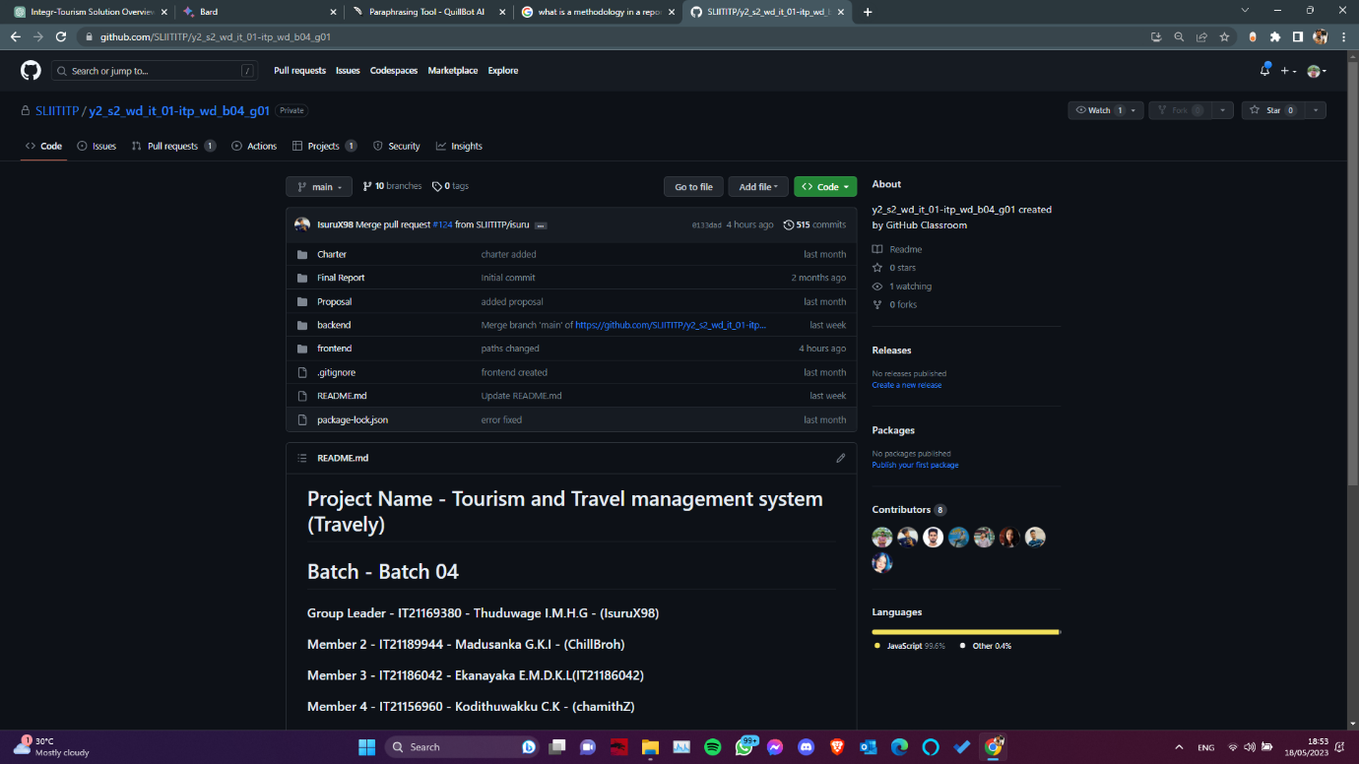

**Our live interview with a tourist:**

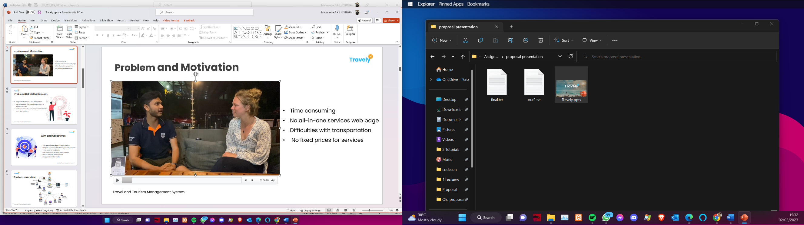

Video link:

<https://drive.google.com/file/d/1twTBC4sqGZyYS6njS4YZBshah_xXZu78/view?usp=sharing>

# Requirements

## Stakeholder analysis

Stakeholder analysis is an essential step in the development of any system or project. It involves knowing and understanding the individuals, groups, or organisations who have a stake in or will be impacted by the system under development. End-users, customers, management, employees, government agencies, and other relevant parties are examples of stakeholders.

**Tourists:**

Tourists are the system's primary users. They want seamless travel experiences, simple booking processes, and easy access to relevant information about destinations, activities, lodging, and dining options. It is critical to understand their preferences, expectations, and pain points when designing a user-friendly and customer-centric system.

**Travel Agencies:**

Travel agencies are essential to the tourism industry. They act as intermediaries for tourists and service providers. It is critical to involve travel agencies as stakeholders to understand their needs for system integration, booking management, itinerary planning, and tourist communication.

**Service Providers:**

Hotels, transportation companies, tour operators, restaurants, and other tourism-related businesses are examples of service providers. Engaging service providers as stakeholders allows you to better understand their requirements for effective inventory management, availability updates, reservation systems, and coordination with other providers.

**Government and Regulatory Bodies:**

Through policies, regulations, and licencing requirements, the government and regulatory bodies have a significant impact on the tourism industry. Involving them as stakeholders helps to ensure regulatory compliance, data privacy, security standards, and legal framework adherence.

**Technology Partners and Suppliers:**

Technology partners and suppliers provide the infrastructure, software, and support required for the development and maintenance of the system. Engaging them as stakeholders allows for a better understanding of their technical needs, system integration capabilities, data management, and security concerns.

**Management and Project Sponsors:**

Management and project sponsors are invested in the system's successful development and implementation. Their assistance and input are critical in defining project objectives, allocating resources, establishing priorities, and ensuring alignment with business objectives.

## Requirements analysis

### Functional Requirements

* + User Management
  + Financial Management
  + Online Booking and Reservation System
  + Tour Packages Management
  + Payment Processing
  + Inventory Management
  + Customer Management
  + Reporting and Analytics

### Non-functional Requirements

* + Security
  + Scalability
  + Availability
  + Usability
  + Efficiency
  + Accuracy
  + Maintainability

### Technical Requirements

* Frontend - React js
* Backend - Node js, Express js
* Database - Mongo DB, FireBase, Cloudinary
* Backend Testing – Postman API
* Frontend Host – Netlify
* Backend Host – Heroku
* Integration of project - GitHub

## Requirements modeling

* Use Case Diagrams: Interactions between actors (users or external systems) and the system.
* Activity Diagrams: Illustrate the flow of activities or processes within the system.
* Class Diagrams: Represent the static structure of the system, including the classes, their attributes, relationships, and methods.
* Entity-Relationship Diagrams: logical structure of the system's data entities and their relationships

# Design and Development

# Testing

# Evaluation and Conclusion

# References

|  |  |
| --- | --- |
| [1] | .. F. A. M. A. a. M. J. Khan, “ "A Comprehensive Review of Online Travel Booking Systems"”. |
| [2] | A. M. &. W. S. S. Morrison, “"Destination partnerships for sustainable tourism: Conceptualizing and measuring partnership quality,",” 2020. |